**CS-2003L**

**DATABASE SYSTEMS LAB**

**HOSPITAL MANAGEMENT SYSTEM**

**Project Report By**

**Muhammad Mansoor cs181073**

**Group Members:**

Syed Sohaib Hassan cs181027

Muhammad Fazeel cs181010

Shahroz Hasan Khan cs181052

# Introduction

A Hospital Management System is an integrated information system for managing all aspects of a hospital's operations. It includes electronic patient’s health records and doctors’ records etc.

# Scope

The main aim of our project is to provide a paper-less hospital up to 90%. It also aims at providing low-cost reliable automation of the existing systems. The system also provides excellent security of data at every level of user-system interaction.

# Module Description

Different module is attached in the project which are used to save the record of the patients, doctors record and details, show the record and details of patients and doctors. Project is also used to print and generate appointment slip.

# 4. Hardware/Software Requirements

## 4.1 Tools

## frontend: c#

backend: mysql database

## 4.2 Libraries, IDE

Visual Studio 2019

# 5. ERD

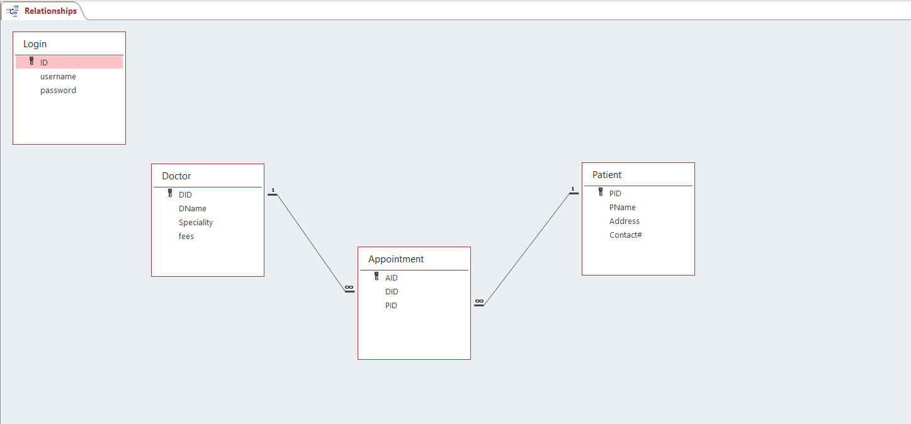

**6. Screen Shots**

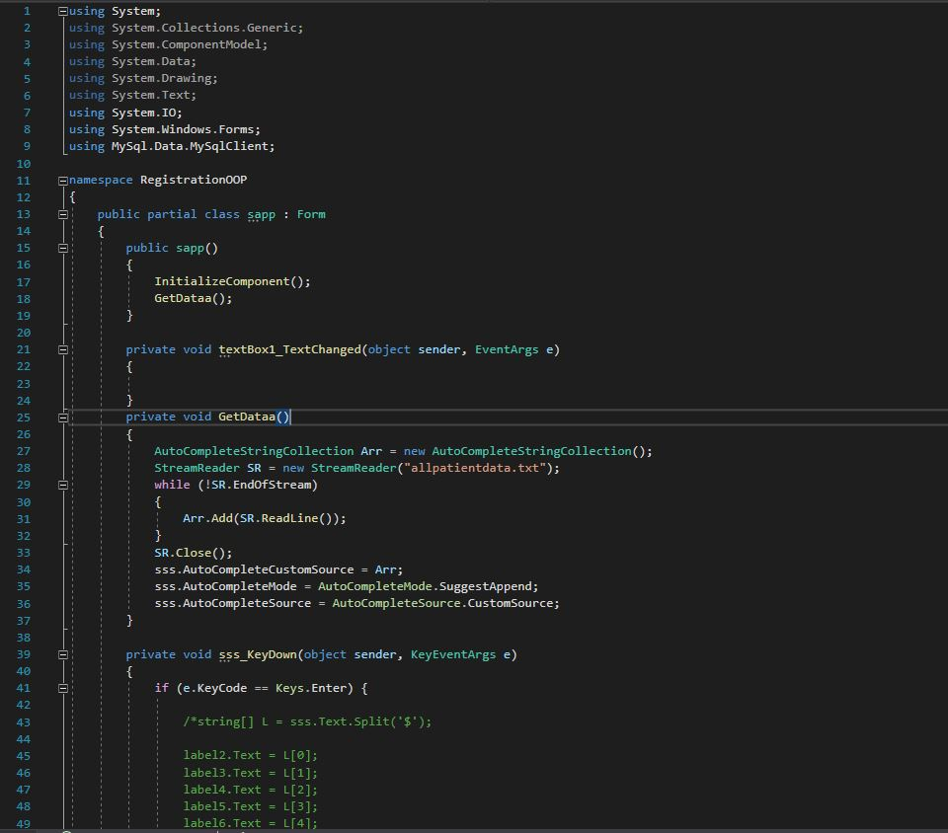

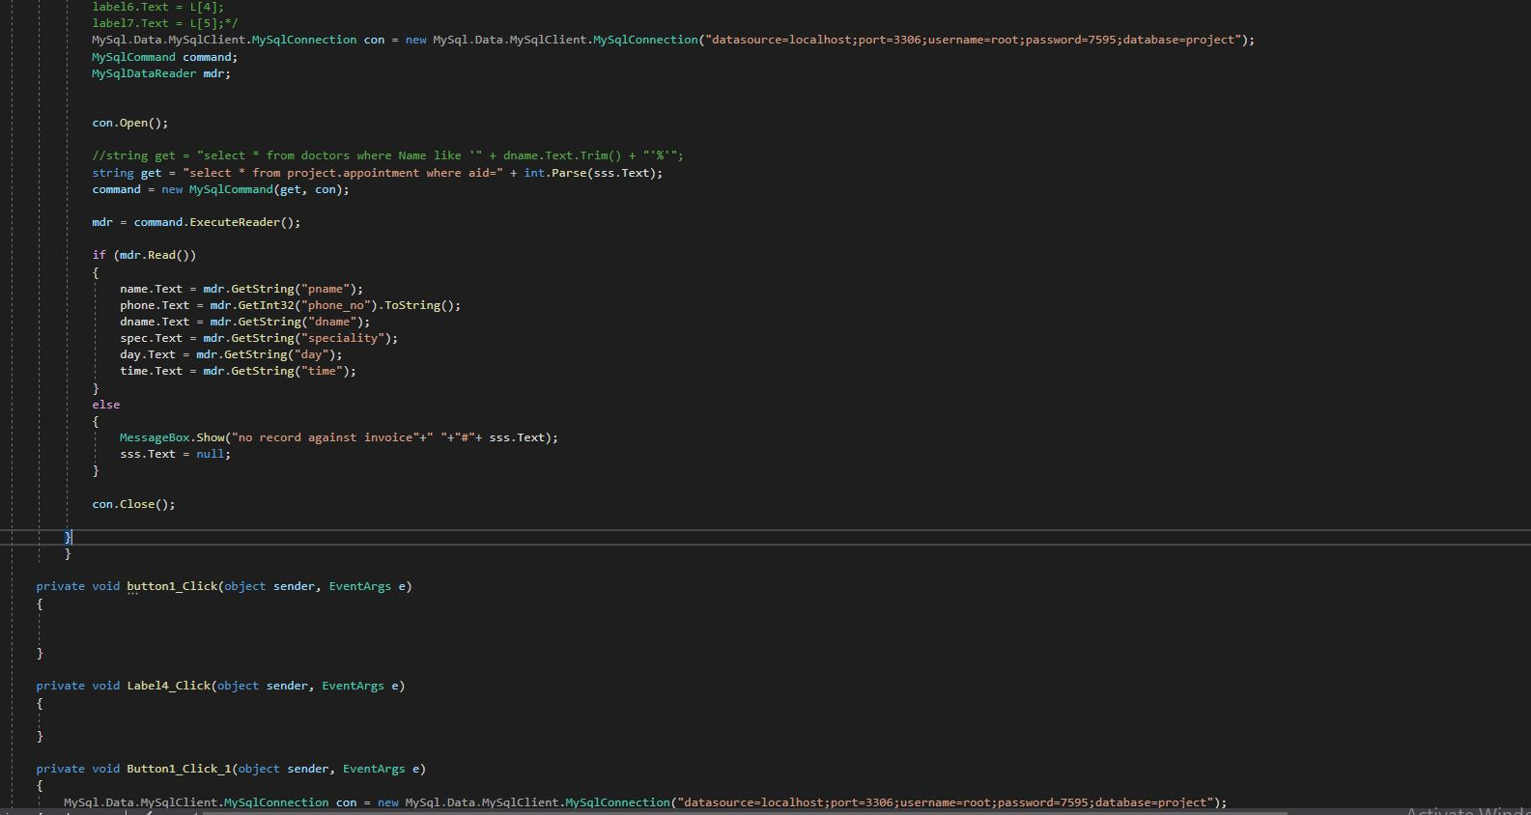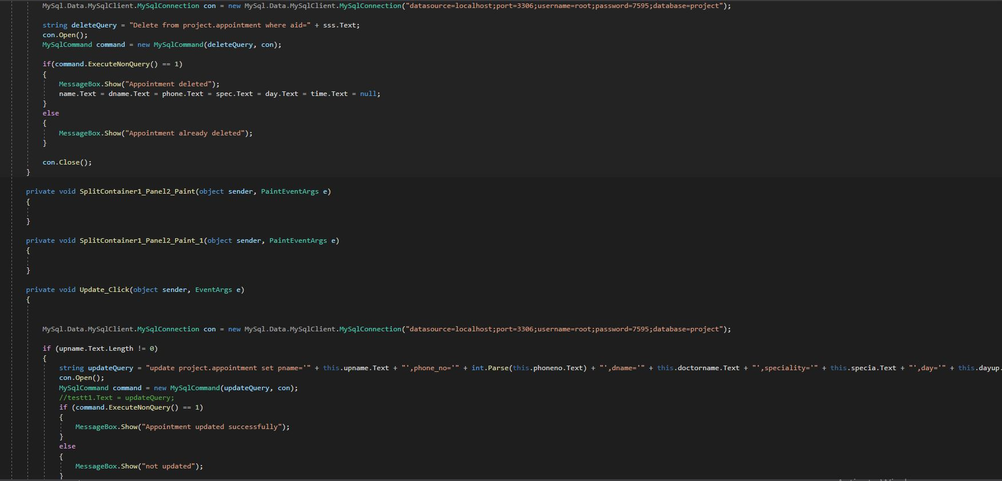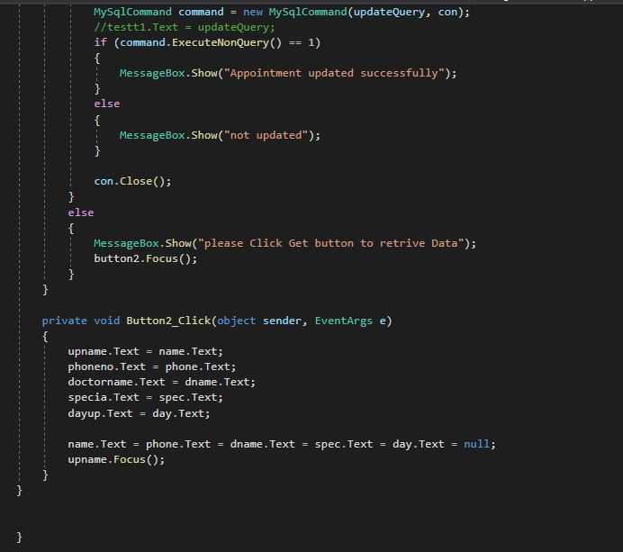

**OUTPUT:**

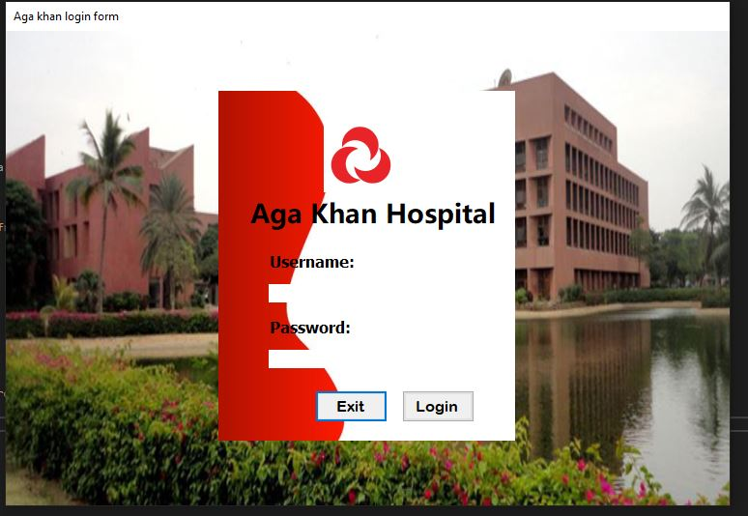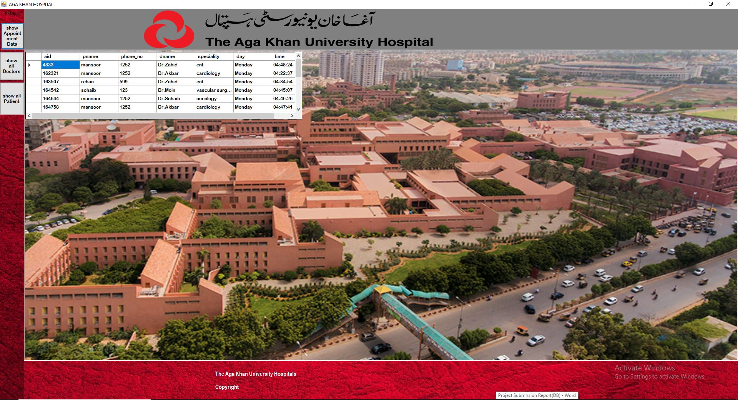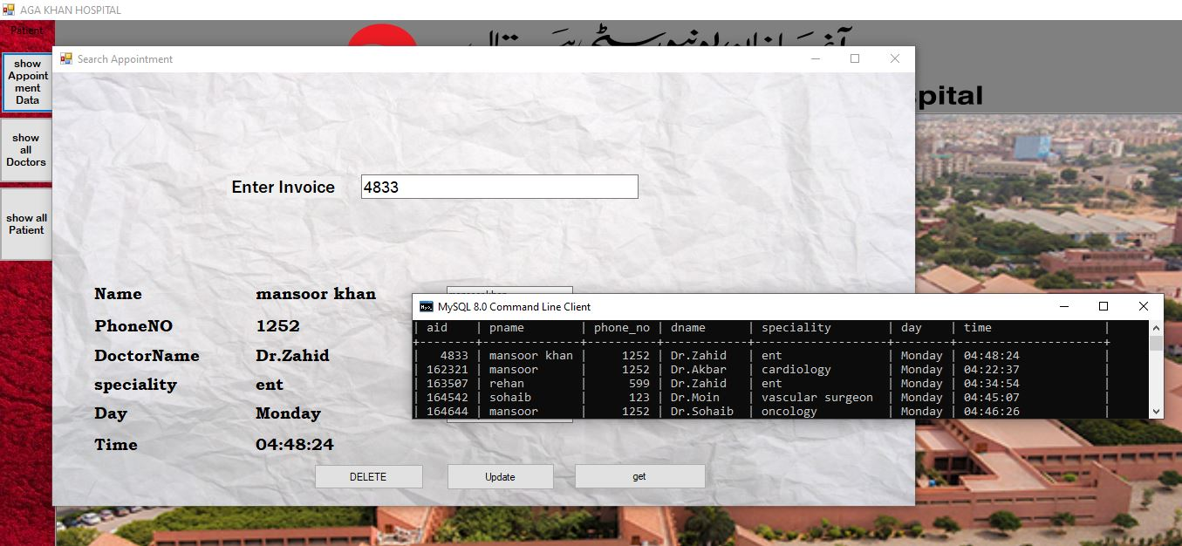

# 7. Gantt Chart

|  |  |  |
| --- | --- | --- |
| **Process state** | **Task** | **Time consumed** |
| State 1: | Project analysis and ERD | 1 day |
| State 2: | Frontend development. | 2 days |
| State 3: | Creation and connection to mysql database. | 1.5day |
| State 4: | Using query to:   * Insert data in database * Searching data from database into grid and labels * Modifying data in database * Delete data from database * Matching data for login form | 3.5 days |
| State 5: | Testing and debugging | 1 day |